Coordination of Entrepreneurs (2023)
WP3/ Development/3.2. «Entrepreneurs Centres»

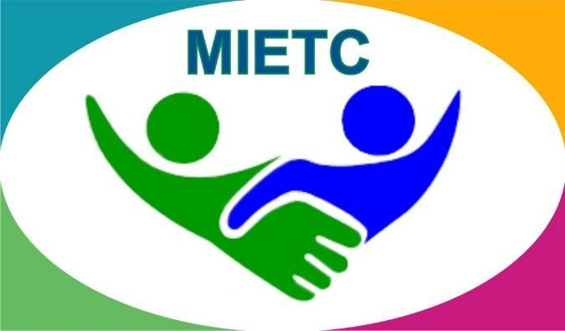
DEVELOPMENT OF A MASTER PROGRAMME IN THE MANAGEMENT OF INDUSTRIAL ENTREPRENEURSHIP FOR TRANSITION COUNTRIES
610198-EPP-1-2019-1-ES-EPPKA2-CBHE-JP

The information and views set out in this publication are those of the authors and do not necessarily reflect the official opinion of the European Union. Neither the European Union institutions and bodies nor any person acting on their behalf may be held responsible for the use which may be made of the information contained therein.

Detailed information is available in the Handbook
https://www.keu.kz/en/section-table/31-materialy/10080-handbook-of-the-entrepreneurs-center.html

A memorandum has been concluded with the Department of State Revenue in the region of Ulytau
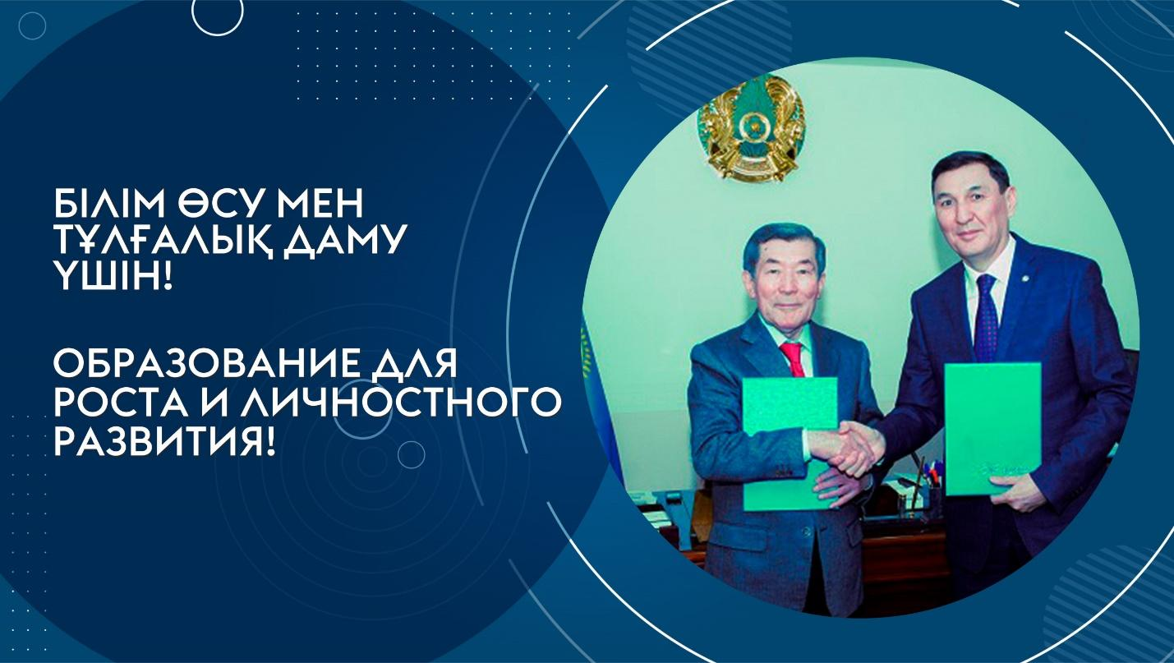
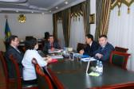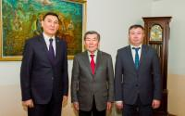
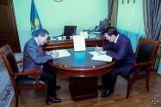
On January 12, 2023, a meeting was held at the university with the head of the State Revenue Department for the Ulytau region of the State Revenue Committee of the Ministry of Finance of the Republic of Kazakhstan, Orynov Galymzhan Kaldykozovich, during which the parties signed a memorandum. The main purpose of the Memorandum is to attract students to practice in the state revenue bodies, to consult on employment.
During the meeting, the Rector of the university said that the main stage of cooperation in terms of practical training is industrial practice, mandatory for both undergraduate and graduate students. That is why the University provides students with places of internship and employment, interacting with diverse commercial, non-profit, as well as government agencies. To create favorable conditions for students and potential employers throughout the year, the university holds Career Days, events dedicated to presentations of various companies and speeches by their representatives.
In turn, G.K. Orynov stressed that the main task of the Department is to ensure the economic security of the state, the legitimate rights and interests of business entities, society and the state, and the implementation of strategies and programs that ensure the formation of state policy to identify and investigate crimes in the field of economic activity, as well as countering the "shadow" economy. In this regard, in order to increase the level of knowledge of students and undergraduates of the University in the field of taxation and customs, permanent working groups will be organized, seminar-meetings, round tables, information and explanatory events will be held.
The event ended with the solemn signing of the memorandum. The parties expressed confidence in building up contacts on all lines of cooperation.

Meeting with representatives of the Karaganda City Police Department
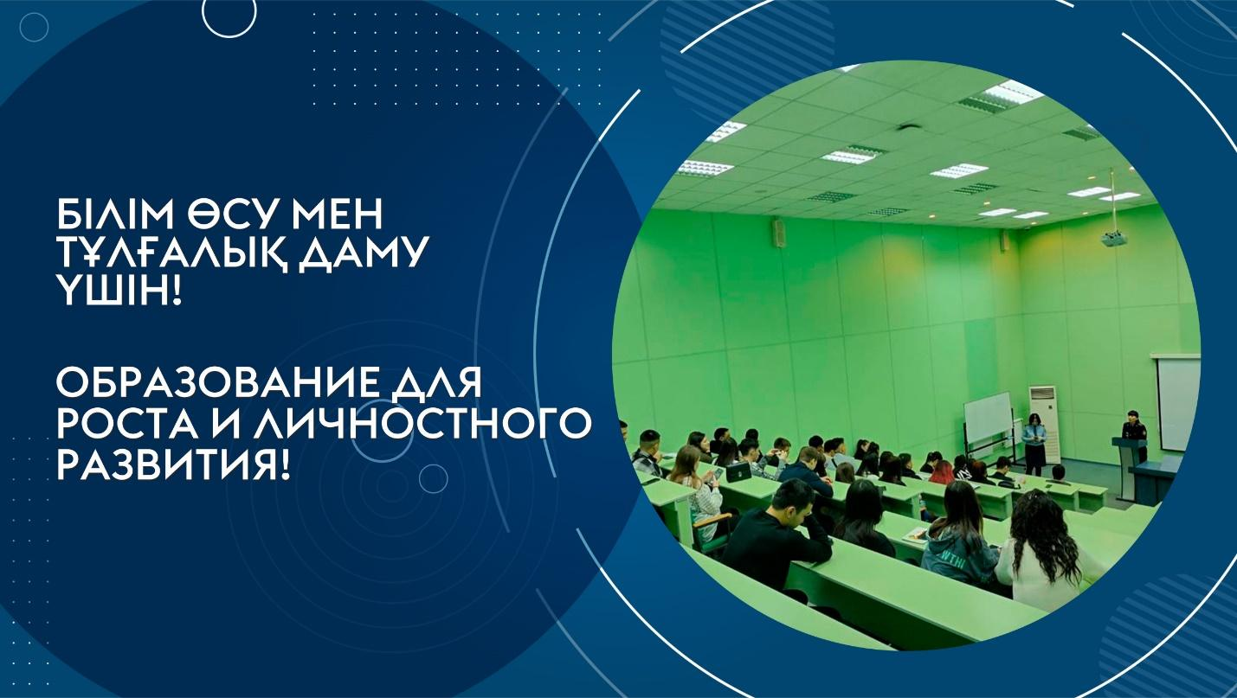
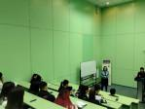
On March 02, 2023, the university hosted a meeting of representatives of the Karaganda city Police Department of the Karaganda region with students of the educational programs "Jurisprudence" and "Judicial law Enforcement".
Employees of the Department of Personnel Policy of the Administrative Department of the city of Karaganda announced the recruitment of candidates for service in the internal affairs bodies, answered all questions about employment in the police.
During the meeting, the tasks, competencies and powers of the internal affairs bodies were also noted, as well as the advantages of service:
- initial training and advanced training at the expense of the employer;
- stable and timely salary with an increase in the size of the official salary depending on the length of service and special rank;
- health improvement benefits, career growth;
- free medical care in departmental medical institutions.
The students received good advice, signed up for testing electronically through the egov e-government portal, and received a list of necessary documents for candidates for ordinary and medium-sized positions.
Employment of graduates is a significant criterion for evaluating the work of any university. Therefore, the organization of such meetings with potential employers is very important.

Master class on the topic: «The Terricon Valley as a launching pad for students»
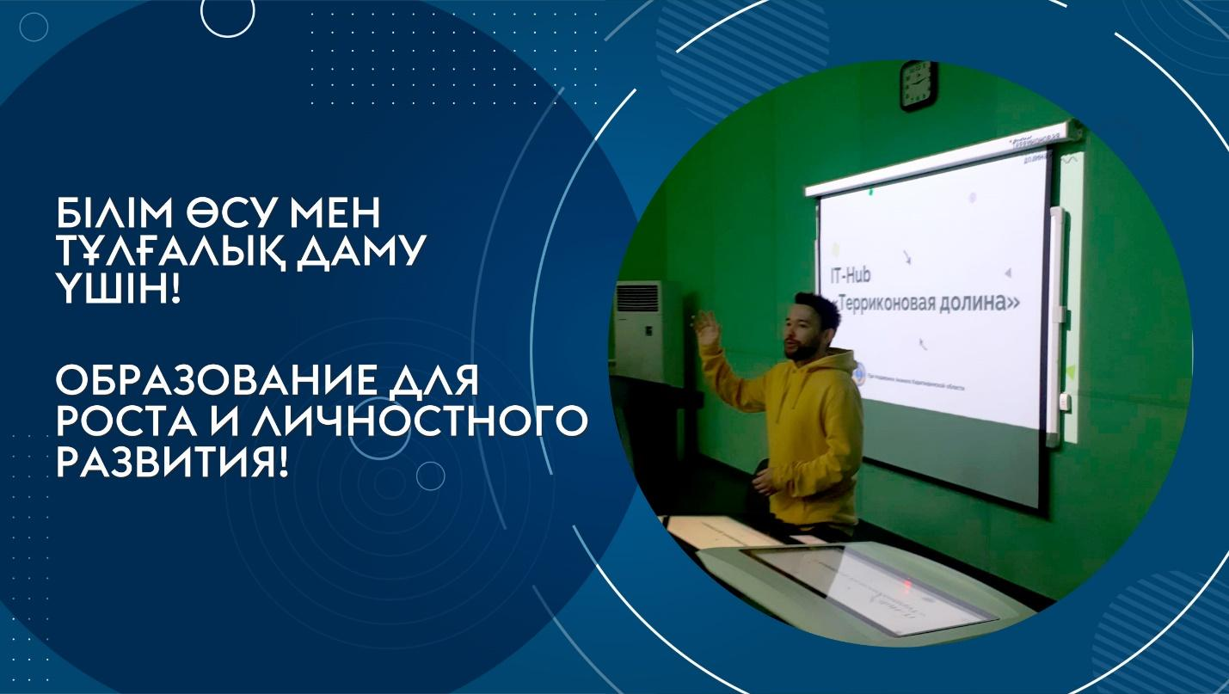
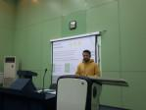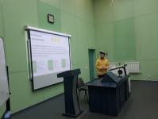
Technological business incubator «Coworking Center «Dostyk» and Research Institute of EPI of Karaganda University of Kazpotrebsoyuz on March 06, 2023 organized a meeting of second and first year students with event manager «IT-Hub Terricon Valley» Lunko Maxim Evgenievich on the topic: «The Terricon Valley, as a launching pad for students».
During the Master class, Maxim Evgenievich told how MGU students would like to participate in various events organized by the «IT-Hub Terricon Valley». During the meeting, Maxim Evgenievich said that free events are regularly held in the IT hub: lectures, meetups, courses, training programs for startups and entrepreneurs. For students, it is an opportunity to make useful acquaintances and develop their business. «IT-Hub Terricon Valley» is an ecosystem that promotes the development of IT and Digital spheres through the training of beginners and experienced specialists.
The students expressed their gratitude for the information provided during the meeting, which turned out to be very informative and fascinating, and expressed their wishes for further cooperation.

«Neuromarketing as a basis for decision-making» - meeting with a practitioner
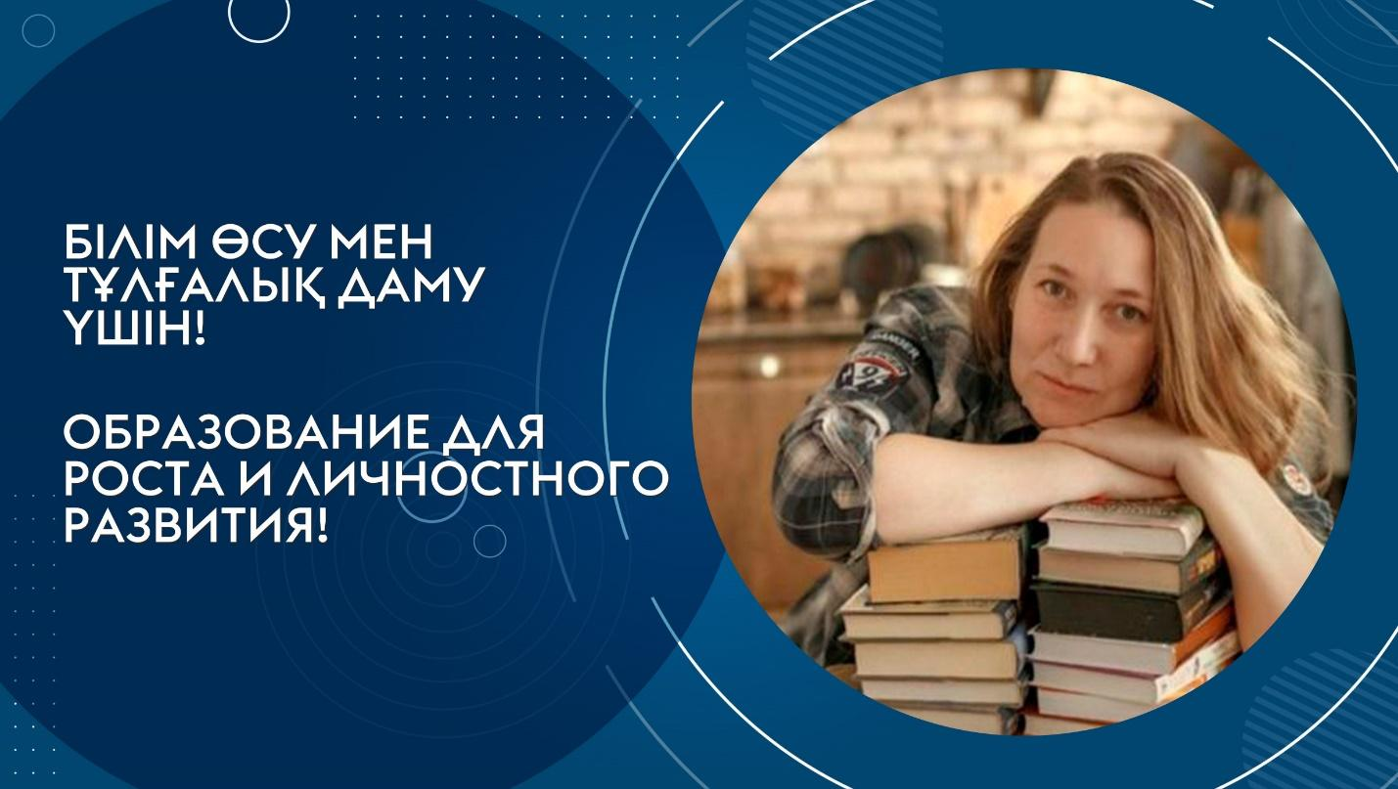
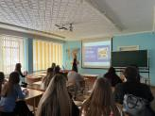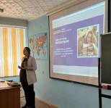
Natalia Abramova, Director of the Brain agency Marketing Agency, revealed a relevant and interesting topic to students of the educational specialty «Marketing» at a meeting on March 16, 2023.
How to create trading offers based on neuromarketing, the psychology of sales, the development of promotions and discounts – this is just not much that Natalia Abramova told about. To obtain practical skills and abilities, students were offered available vacancies and internship after graduation.

Strategic partnership: Memorandum signed with the Department of the Agency of the Republic of Kazakhstan for Civil Service Affairs in Ulytau region
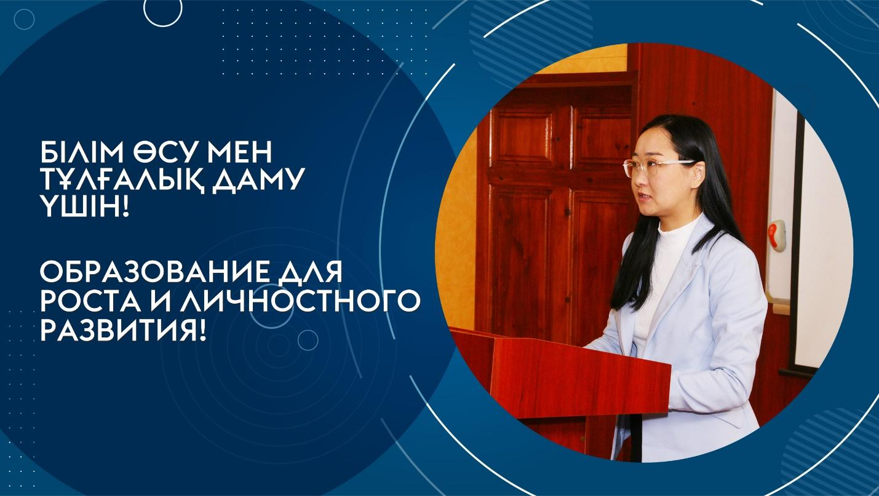
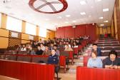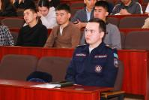
On March 28, 2023, Rector of the University Aimagambetov Yerkara Balkaraevich and Head of the Department of the Agency of the Republic of Kazakhstan for Civil Service Affairs in Ulytau region Akhmetov Berik Mukhamedzhanovich signed a memorandum of cooperation. The purpose of the memorandum is to strengthen and develop cooperation in the field of personnel training for state bodies of the Ulytau region. The most important elements of cooperation are practical training in government organizations, organization of scientific seminars, master classes and conferences.
Representatives of the Department met with our students after the end of the solemn part of the signing of the memorandum.
Kayyr Zhanar Dayyrkyzy – Head of the Civil Service Department of the Agency of the Republic of Kazakhstan for Civil Service Affairs in Ulytau region;
Amirbek Yernur Musauly – Chief Specialist of the Department of Control in the field of Public Service of the Department of the Agency of the Republic of Kazakhstan for Civil Service Affairs in the Ulytau region;
Suleimenova Gulmira Tanatarovna – Chief Specialist of the Department of the Industrial Safety Committee of the Ministry of Emergency Situations of the Republic of Kazakhstan in the Ulytau region;
Nurbol Manatovich Amantaev – Chief Specialist of the Personnel Department of the CSB of the RSU of the Emergency Situations of the Ulytau region of the Ministry of Emergency Situations of the Republic of Kazakhstan (Zhezkazgan);
Kerimbekova Asyl Bazarbekovna – Ulytau regional territorial Inspection of the State Inspection Committee in the Agro-industrial complex of the Ministry of Agriculture of the Republic of Kazakhstan.
The meeting discussed issues of admission to the school of civil servants, selection for public service, probation, career advancement (the principle of meritocracy), as well as a new remuneration system based on a factor-point scale.
The main purpose of such meetings is to attract active and responsible young people to the civil service, who are able to offer fresh ideas and new approaches to solving the tasks facing the state.

Representatives of JSC "Financial Center" met with graduates studying on the basis of the state educational order
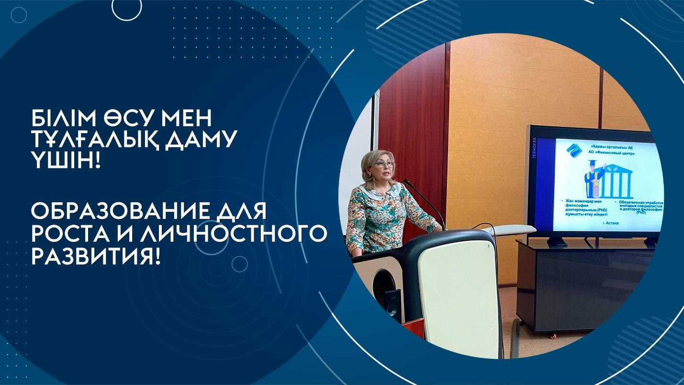
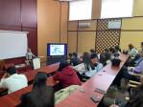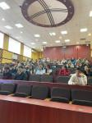
On April 25, 2023, the representative of JSC "Financial Center" Ibraeva Zhanat Sametovna met with graduates studying on the basis of a state educational order on the issues of mandatory grant processing, distribution and employment.
During the visit, a meeting was also held with the Vice-Rector for Academic Affairs and Strategic Development, Doctor of Economics, Professor G.E. Nakipova.
This meeting was attended by students, undergraduates and doctoral students of our university, a total of 50 people were present.
Ibraeva Zh.S. explained the rules for working out state educational grants:
- Since 2021, master's and doctoral students who studied at the expense of the state on a state educational grant must work for 3 years after graduation. At the same time, the rules for working out from 2021 have been simplified: graduates can work out the required period not only in state organizations, as previously required, but also in private ones.
- A norm has been introduced to reimburse the expenses incurred by the state for training, in proportion to the actual period of study. That is, if a student studied for two years on a grant and then transferred to a paid form, he will have to work out the time corresponding to the number of years of free training. The same rule applies in the case when students studying for a fee enter through a competition for vacant places on a grant.
- The referral for working out is provided in advance by the Commission for the Distribution of graduates created by the university. The graduate must start working from September 1 in the year of graduation from a higher educational institution.
- In case of non-fulfillment of obligations for working out, responsibility for reimbursement of training costs is provided.
- It is not necessary to work out when paying for training expenses, as well as in the case of: absence of vacancies in the locality at the place of residence, work or service of the spouse; disability of group I and II; admission for further study to residency based on a state educational order, master's degree, doctoral degree; pregnancy; if persons have, and also independently raise a child (children) under the age of three.
At the end of the meeting, the graduates asked questions about working out, they received a full detailed answer to all the questions posed.

Meeting of students with representatives of "KamaTyresKZ" LLP
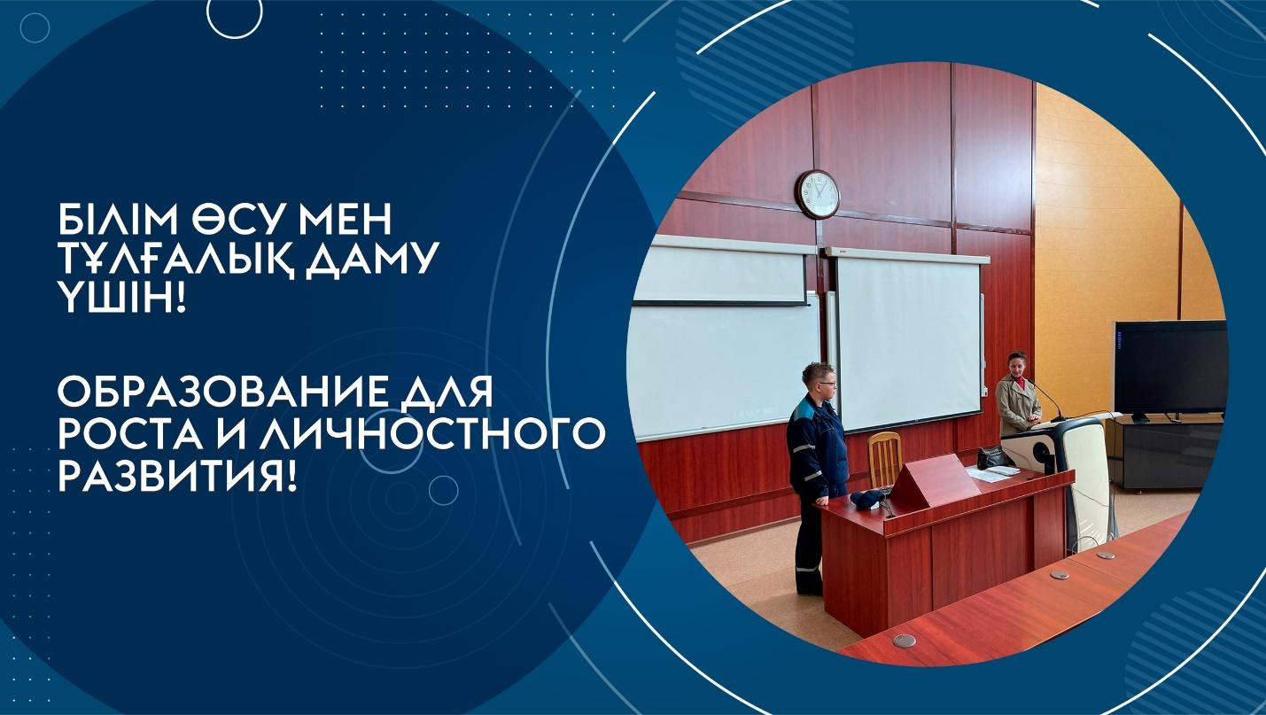
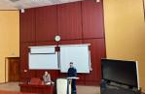
On April 27, 2023, representatives of KamaTyresKZ LLP met with students of the educational programs "Logistics", "Standardization, Certification and Metrology", "Food Technology", organized by the University Resource Center.
The KamaTyresKZ LLP plant is one of the largest projects of republican significance in the Karaganda region. At the moment, the plant is at the stage of commissioning with subsequent entry into commercial operation. In this regard, the company needs professional administrative, managerial and technical personnel.
A representative of the personnel service of the plant and a process engineer told about the basic requirements for employment, safety regulations, rationing of working hours, etc. To obtain practical skills and abilities, students were offered available vacancies and the opportunity to complete professional and pre-graduate internships in the company.
Students asked potential employers questions about the features and conditions of their future profession, which gives them confidence in solving the problem of future employment and self-realization.

Consultation on business creation and development by experienced entrepreneurs of the region
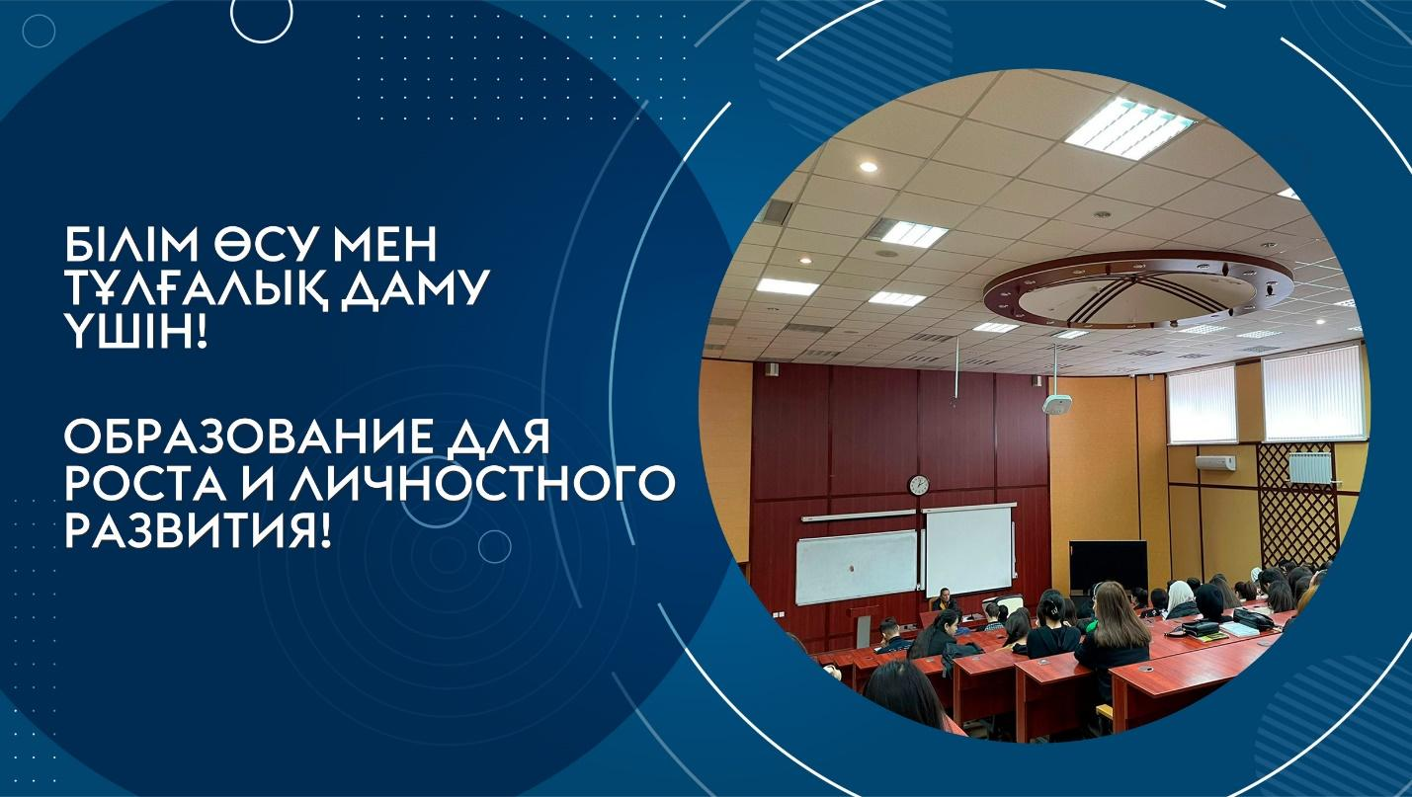

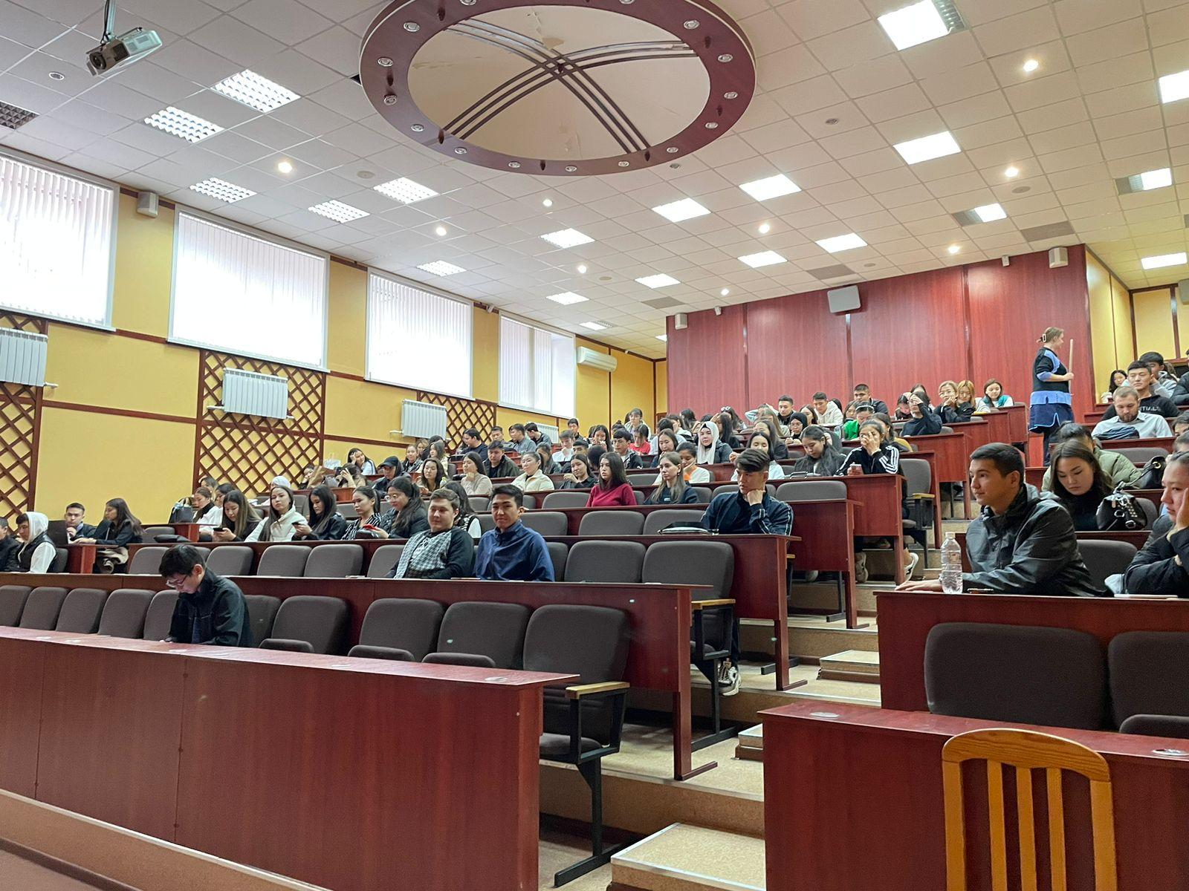

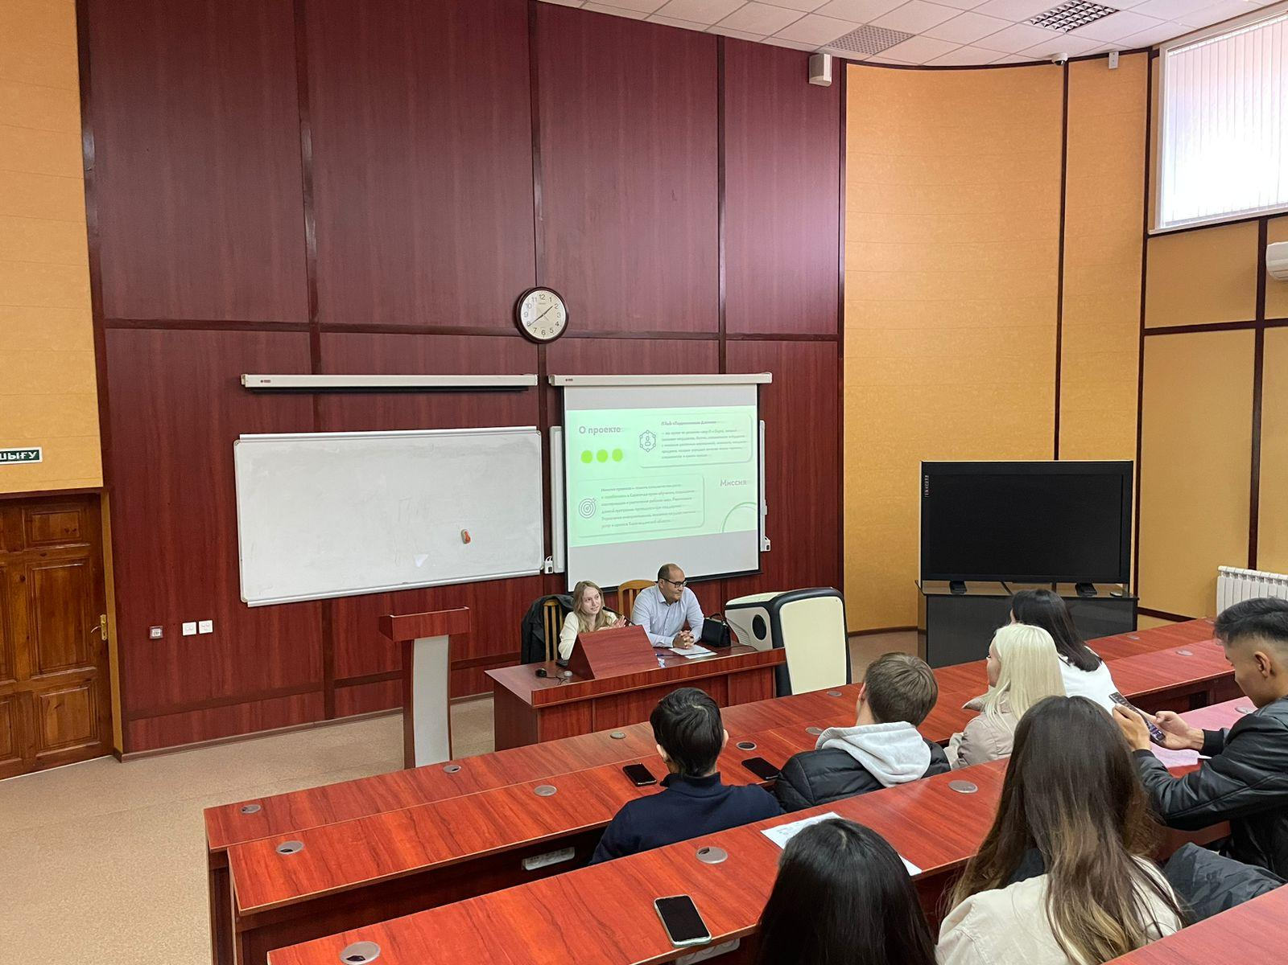
In April 2023, together with NCE “Atameken”, meetings of graduate students with entrepreneurs of the region were organized, in which they took part:
1) Abt Nikolay Viktorovich - Director of the "Organizing Committee of the MCC" LLP
2) Aleskerov Vladimir Vladimirovich – Director of A.V.Group LLP;
They shared their experience of creating and running a business, and also told how to avoid mistakes at the initial stage of their own business. they explained where to start their entrepreneurial activity, where to get an idea for their business, how to competently assemble their team and build work with clients.

Students met with a well-known entrepreneur
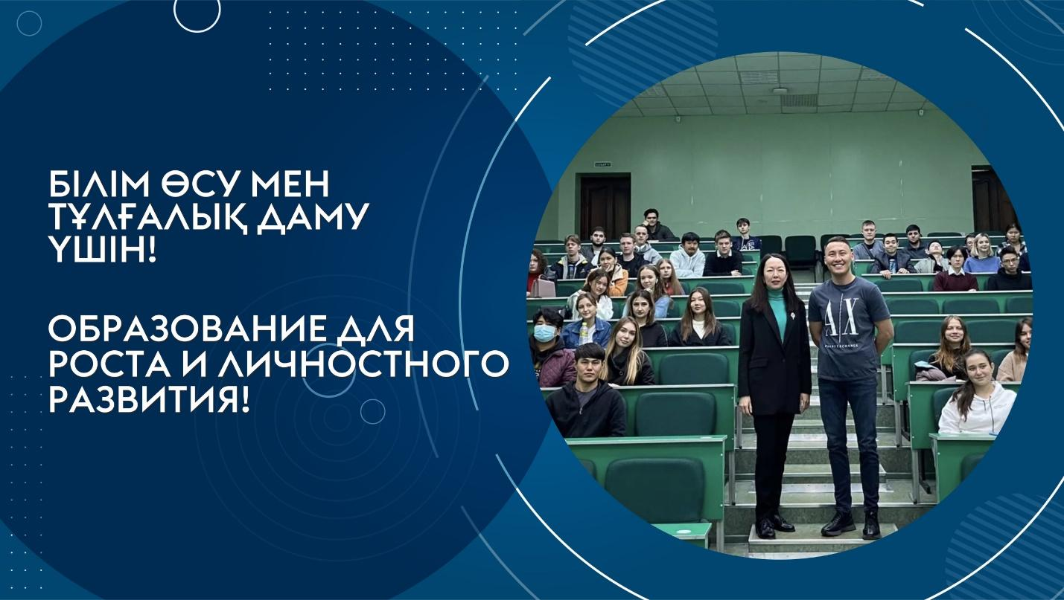
On October 03, 2023, Aizat Alkenov, an entrepreneur, co-owner of the Belady chain of stores, visited our university. Belady is a large chain of women's clothing and accessories stores, has 6 stores in Kazakhstan.
Aizat Alkenov shared with the audience of students the history of his formation as an entrepreneur, the experience of forming initial capital, the features of implemented business projects, examples of entrepreneurial risks that he had to face.
Also attended an open class of PhD doctor, associate professor Salauatova D.M. in the discipline "Entrepreneurship". Since the final work of the students in the discipline "Entrepreneurship" is the development and protection of a business project in the chosen direction, they were active and asked practical questions and consulted on their topics, as well as interested in the current trends in the field of entrepreneurship.
It was useful for students to listen to a speaker who spoke about his business experience.

Experience, practice and development of professional competencies
The University strives in every possible way to enable students to acquire the most valuable thing for employment in the future – work experience in the specialty. Practical orientation is the main feature of modern education today
Field practical classes as an active form allows the student to realize the theoretical knowledge gained in lecture classes.
On September 27, 2023, a field lesson was organized for students of the Marketing educational program at the Bacchus Auto Center, which is an official dealer of Chevrolet, LADA, Kia, JAC, JETOUR and has been operating on the market for more than 17 years.
The purpose of the field session was to study the practical application of modern marketing tools and technologies in the activities of domestic companies.
The first deputy General Director of the Bacchus Auto Center, Kosman Yergabilevich Imanbayev, introduced the students to the company's marketing policy, market trends, channels for promoting the products offered, loyalty programs and strategies used.
He clearly demonstrated the work of the CRM system, which is necessary for maintaining a customer base, automating sales and working with transactions.
The meeting was held in the format of an interview, the students were satisfied, having received answers to their questions from a professional in their field.
Conducting field classes for students in specialized organizations contributes to the expansion of the acquired knowledge in practice and the formation of the worldview of the future specialist.

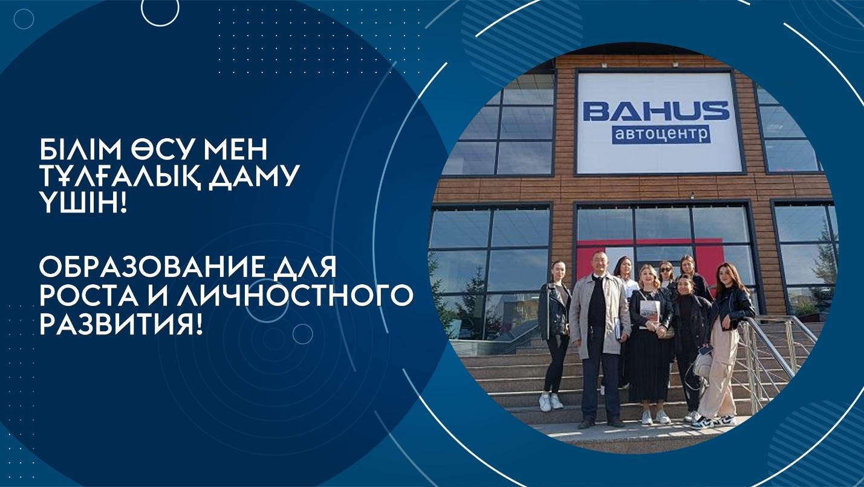

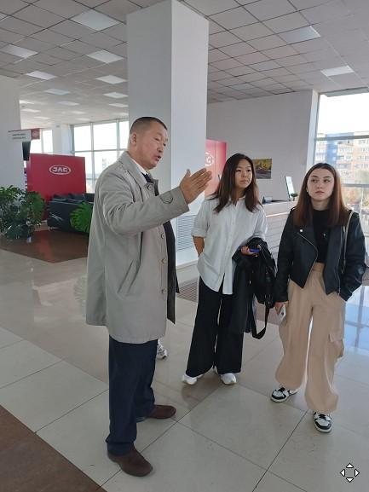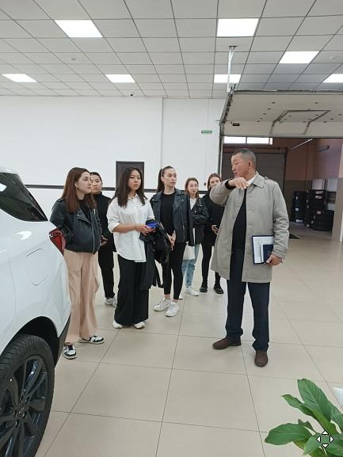

Meeting with Sergey Perov, Head of the Department of the Anti-Corruption Agency of the Republic of Kazakhstan in the Karaganda region
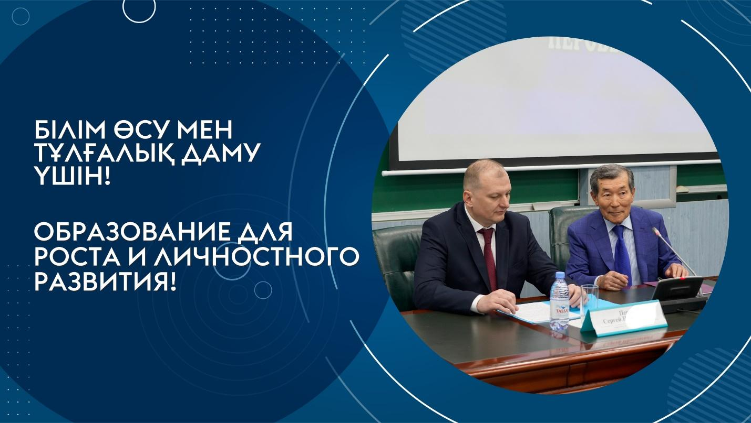
A meeting was held with the head of the Department of the Agency of the Republic of Kazakhstan for Combating Corruption in the Karaganda region Sergey Perov at the Karaganda University of Kazpotrebsoyuz with the teaching staff and students of the university. The meeting was held in the format of discussion and exchange of views. During the speech, the head of the Department assessed the material and technical base of the university, then spoke about the activities of the Department, voiced cases on solved problems of citizens with the participation of the Anti-Corruption Service. Deputy Head of the Prevention Department A.Myngishev provided information on the implementation of Anti-Corruption policy in the region. At the end of the meeting, Asylbekova Leyla Umurzakovna, Director of the International Academy of Competence Development LLP, conducted a Leadership training, which voiced the main competencies for a civil service employee.
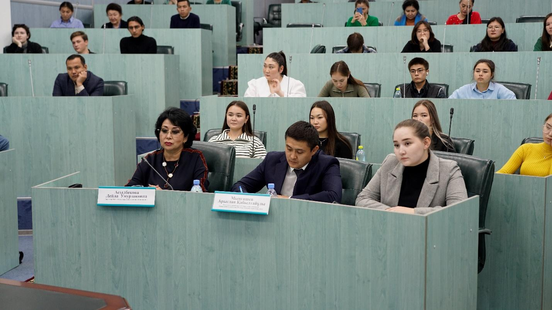

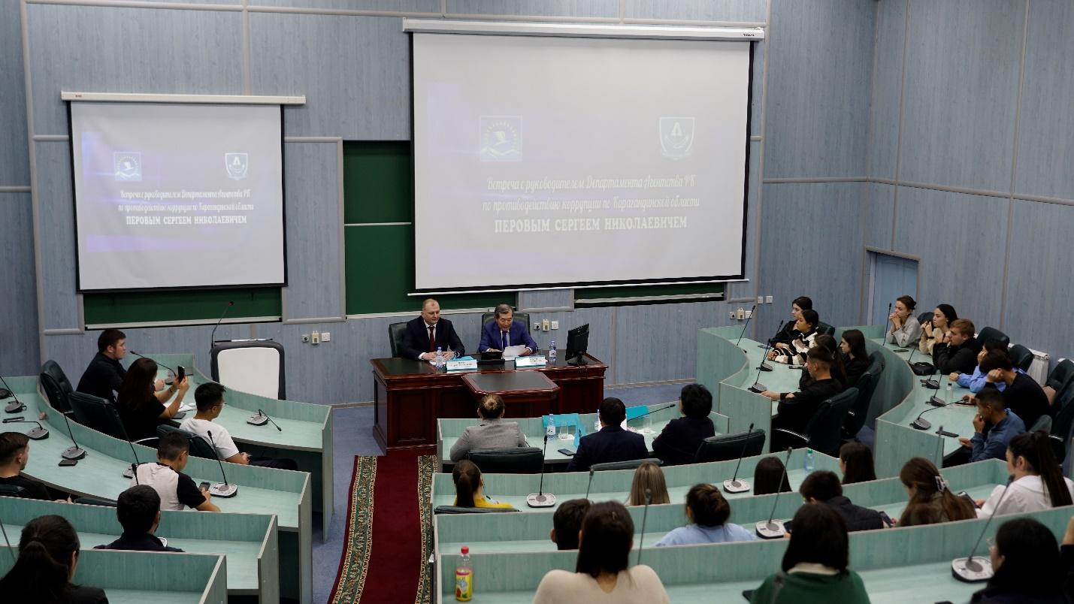

School of a young civil servant
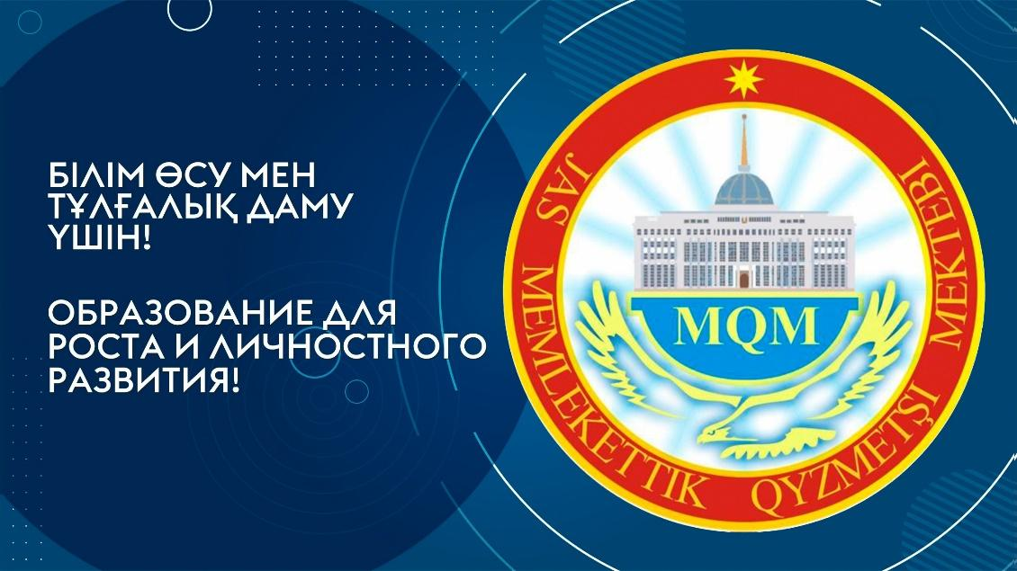
A school of young civil servants has been opening its doors in the Karaganda region for more than 15 years. The project is aimed at attracting talented and active young people to work in the civil service, developing their qualification abilities and professional skills. The School of a young civil servant is a bridge between promising youth and the state apparatus.
To explain this project, on September 12, 2023, the Director of the Academy of Public Administration under the President of the Republic of Kazakhstan for the Karaganda region Baybosynov Yerikzhan Berikbayevich and the chairman of the Council of Business Women of NCE Atameken Shiller Marina Vasilyevna visited the Karaganda University of Kazpotrebsoyuz. Our students were fully informed about the "School of a Young Civil Servant".
This project is aimed at popularizing public service among young people and attracting the most talented and promising of them to the civil service.
The project implementation includes several stages: acceptance of documents for participation in the project, selection, training and internship.
Students were asked a lot of questions, to which they received exhaustive answers and expressed great interest in enrolling in training. This project is very useful for young people. Thanks to it, students will be able to learn useful information in the field of public service and feel the burden of responsibility of the service.
